Class Test 04 – Set A

CSE 437 – Pattern Recognition

Department of Computer Science and Engineering

University of Asia Pacific

Total Marks: 20 Time: 30 Minutes

Q1. Determine what logic gate(s) do the following Artificial Neural Network simulates— [12]

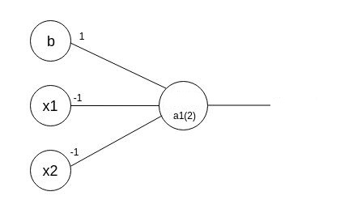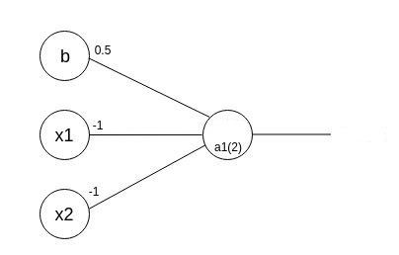

Q2. What is the difference between McCulloch and Pitts model and Single Neuron Perceptron model? Indicate with necessary equations and illustration. [8]